HOLY HEARTS SCHOOL, KABIR NAGAR
CLASS – XI (MATHEMATICS)
ANNUAL EXAMINATION (2024-25)
DATE - / 02 / 2025 MM – 80
General Instructions:
- This Question paper contains - five sections A, B, C, D and E. Each section is compulsory. However, there are internal choices in some questions.
- Section A has 18 MCQs and 02 Assertion-Reason based questions of 1 mark each.
- Section B has 5 Very Short Answer (VSA) - type questions of 2 marks each.
- Section C has 6 Short Answer (SA) - type questions of 3 marks each.
- Section D has 4 Long Answer (LA) - type questions of 5 marks each.
- Section E has 3 source based/case based/passage based/integrated units of assessment (4 marks each) with sub parts.

SECTION A
I Multiple Choice Questions (1 mark each)
1. A $∩$ B = B, then
A. A $⊆$ B B. B $⊆$ A C. A = $∅$ D. B = $∅$
2. Let A = {x : x $∈$R, x $>$ 4}and B = { x : x $∈$R, x $<$ 5}. Then A $∩$ B =
A. (4, 5] B. (4, 5) C. [4, 5) D. [4, 5]
3. If set A has p elements, B has q elements, then the number of elements in A $×$ B is
A. p + q B. p + q + 1 C. pq D. p²

4. Let f(x) = x, g(x) = $\frac{1}{x}$ and h(x) = f(x)g(x). Then h(x) = 1 for
A. $x∈R$ B. $x ∈Q$ C. $x ∈R-Q$ D. $x∈R, x ≠0$
5. If $\tan{x+ \sec{x= \sqrt{3}, 0<x<\frac{π}{2}}}$, then x is equal to
A. $\frac{5π}{6}$ B. $\frac{2π}{3}$ C. $\frac{π}{6}$ D. $\frac{π}{3}$
6. $\sin^{2}{\frac{π}{18}+ \sin^{2}{\frac{π}{9}+ }}\sin^{2}{\frac{7π}{18}+\sin^{2}{\frac{4π}{9}} =}$
A. 1 B. 4 C. 2 D. 0
7. If i² = -1, then the sum of $i+i^{2}+i^{3}+…$upto 1000 terms is equal to
A. $1$ B. $-1$ C. $i$ D. $0$
8. The amplitude of $\frac{1}{i}$ is equal to
A. 0 B. $\frac{π}{2}$ C. $-\frac{π}{2}$ D. $π$
9. If f(x) = $x\sin{x}$ then $f^{'}\left(\frac{π}{2}\right)$ =
A. 0 B. $1$ C.$-1$ D. $\frac{1}{2}$
10. The solution set of the inequation $\left|x+2\right|≤5$ is
A. (-7,5) B. $[-7, 3]$ C.$[-5, 5]$ D. $(-7, 3)$
11. The shaded part of the number line in fig can also be described as
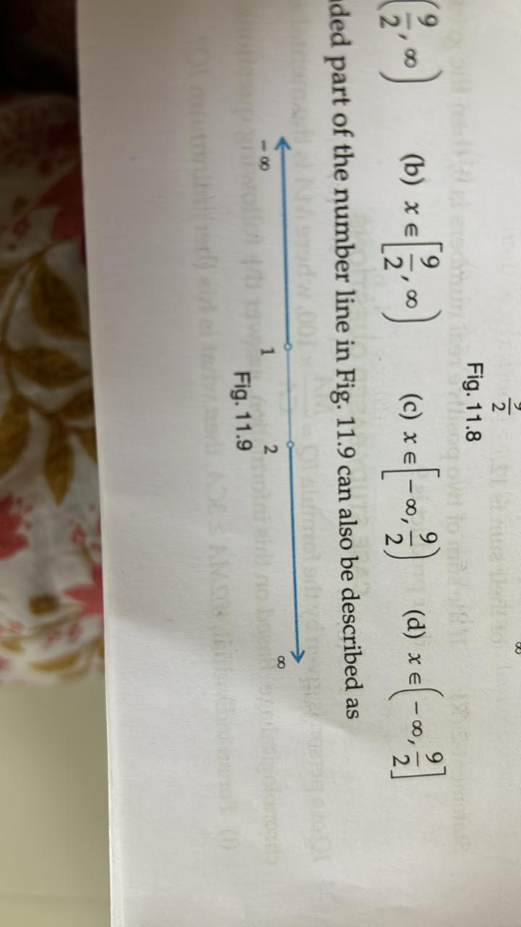
A. $\left(-∞,1\right)∪\left(2,8\right)$ B. $\left(-∞,1\right]∪[2,8)$
C. (1,2) D. [1,2]
12. Among 14 players, 5 are bowlers. In how many ways a team of 11 may be formed with at least 4 bowlers.
A. 265 B. 263 C. 264 D. 275
13. The third term of a G.P. is 4. The product of first 5 terms is:
A. 4³ B. 4⁵ C. 4⁴ D. none

14. Three vertices of a parallelogram taken in order are (-1, -6), (2, -5) and (7,2). The fourth vertex is:
A. (1, 4) B. (4, 1) C. (1,1) D. (4,4)
15. The distance of the point P(1, -3) from the line 2y – 3x = 4 is
A. 13 B $\frac{7}{\sqrt{13}}$ C. $\sqrt{13}$ D. none
16. The eccentricity of hyperbola 9y² - 4x² = 36
A. $\sqrt{13}$ B. $\frac{\sqrt{13}}{2}$ C. $\frac{9}{2}$ D. none
17. If A and B are any two events having P(A$∪$ B) = $\frac{1}{2}$ and P$\overline{\left(A\right)}$= $\frac{2}{3}$ , then the probability of $\overline{A}∩B$is
A. $\frac{1}{2}$ B. $\frac{2}{3}$ C. $\frac{1}{6}$ D. $\frac{1}{3}$
18. Equation of x-axis is considered as
A. $y=0, z=0$ B. $z=0, x=0$
C. $x=0, y=0$ D. $none$
Assertion-and-Reason Type
Each question consists of two statements, namely, Assertion (A) and Reason (R).For selecting the correct answer, use the following code:
(a) Both Assertion (A) and Reason (R) are the true and Reason (R) is a correct explanation of Assertion (A).
(b) Both Assertion (A) and Reason (R) are the true but Reason (R) is not a correct explanation of Assertion (A).
(c) Assertion (A) is true and Reason (R) is false.
(d) Assertion (A) is false and Reason (R) is true.

19. Assertion (A) :Three letters can be posted in 5 letter boxes in 5³ ways.
Reason (R) : Out of 5 distinct items 3 items can be chosen in $5_{C_{3}}$ ways.
20. Assertion (A) : The mean of first n natural numbers is $\frac{n+1}{2}$.
Reason (R) : The mean of the square of first n natural numbers is $\frac{n^{2}+1}{2}$.
SECTION B
II Very short answer type questions (2 marks each)
21. If A and B are two sets and U is the universal set such that n(U)=700, n(A) = 200, n(B) = 300 and n(A $∩B$) = 100. Find n(A’ $∩$ B’).
22. Let R be the relation on the set N of natural numbers defined by
R = {(a,b) : a + 3b = 12, a$ϵ N , b ϵ N$}. Find domain and Range of R.
OR
Find x and y, if (x + 3, 5) = (6, 2x + y).
23. Find the equation of circle whose radius is 6 and the centre is at origin.
OR
The focal distance of a point on the parabola y² = 12x is 4. Find the abscissa of this point.
24. Find the distance between the points P (-2, 4, 1) and Q(1, 2, -5).
25. Evaluate: $\lim_{x →2}{\frac{x^{2}-5x+6}{x^{2}-4}}$

SECTION C
III Short answer type questions (3 marks each)

26. Of the members of three athletic teams in a certain school, 21 are in the basketball team, 26 in hockey team and 29 in the football team. 14 play hockey and basketball, 15 play hockey and football, 12 play football and basketball and 8 play all the three games. How many members are there in all ?

27. Find the domain and range of function f(x) = $\frac{1}{\sqrt{x-\left[x\right]}}$.

28. Find the value of x³ + 7x² – x + 16, when x = 1 + 2i.

OR

If a + ib = $\frac{{\left(x+i\right)}^{2}}{2x^{2}+1},$prove that a² + b² = $\frac{{\left(x^{2}+1\right)}^{2}}{{\left(2x^{2}+1\right)}^{2}}$

29. The perpendicular from the origin to a line meets it at the point (-2,9), find the equation of the line.

OR

Find the equation of a line passing through the point (2,3) and parallel to the line 3x – 4y + 5 = 0.

30. Find a, if 17th and 18th terms in the expression of (2 + a)⁵⁰ are equal.

OR

Find the middle term in the expression of : ${\left({2x}^{2}- \frac{1}{x}\right)}^{7}$

31. Calculate mean deviation about mean from the following data:
x_{i} | 3 | 9 | 17 | 23 | 27
f_{i} | 8 | 10 | 12 | 9 | 5

SECTION D
IV Long answer type questions (5 marks each)
32. Prove that sin A sin($\frac{π}{3}-A$) sin($\frac{π}{3}+A$) = $\frac{1}{4}\sin{3A}$
OR
Prove that $\left(1+ \cos{\frac{π}{8}}\right)\left(1+ \cos{\frac{3π}{8}}\right)\left(1+ \cos{\frac{5π}{8}}\right)\left(1+ \cos{\frac{7π}{8}}\right)$ = $\frac{1}{8}$
33. Find three numbers in G.P. whose sum is13 and the sum of whose square is 91.
34. Three coins are tossed once. Find the probability of getting
(i) all heads (ii) at least two heads
(iii) at most two heads (iv) no heads
(v) Exactly one tail
35. Evaluate: $\lim_{x →0}{\frac{\tan{x-\sin{x}}}{x^{3}}}$
OR
Evaluate: $\lim_{x →\frac{π}{4}}{\frac{\sin{x-\cos{x}}}{x-\frac{π}{4}}}$
SECTION E
V Case Study Based Questions (4 marks each)
36. In a certain city, all telephone numbers have 8 digits. City is divided into 6 zones. Each zone is allotted a specific non-zero digit, which is used as first digit of all telephone number of that zone.

Based on the above information, answer the following questions.
- How many different telephone numbers are there in each zone, if the digit on the first place is not used again?
- How many different telephone numbers are there in each zone, with all digits distinct?
- How many different telephone numbers are there in each zone, if repetition of digit is allowed?
- How many different telephone numbers are there in a city, if there
is no restriction?

37. The mean and standard deviation of some data for the time taken to complete a test are calculated with the following result.
Number of observations = 25; Mean = 18.2 seconds; Standard deviation = 3.25 seconds.
Further, another set of 15 observations x₁, x₂…x₁₅ also in second is now available and we have $\sum_{i=1}^{15}{x_{i}=279 and \sum_{i=1}^{15}{{x_{i}}^{2}}=5524.}$

Based on the above information, answer the following question.
1. What is the sum of all 40 observations?
2. What is the mean of all 40 observations?
3. What is the sum of squares of all 40 observations?
4. What is the standard deviation of all 40 observations?
38. A rod AB of length 15 m slides between a horizontal bar and vertical bar. A point P is taken on the rod in such a way that AP equals to 6 m.
Based on the above information, answer the following questions. 1. Taking the coordinate axis along the horizontal and vertical bar,
find the equation of the path tracked by point P.
2. Find the length of major and minor axis of the curve obtained in 1. 3. What is the eccentricity of conic obtained in 1?
4. What are the coordinates of foci of the conic obtained in 1?

